American University of Sharjah  College of Engineering  Dept of Computer Science & Engg  P. O. Box 26666  Sharjah, UAE |  | Lab Instructor: Salsabeel Shapsough  Office: ESB-1010A  Phone: 971-6-5154948  e-mail: sshapsough@aus.edu  Semester: Fall 2024

Lab #2 – Introduction to Logic Gates – Breadboard
Objectives
- Use of switches as inputs and LEDs as outputs.
- Understand and test operations of basic logic gates.
- Determine experimentally the truth tables for the AND, OR, and inverter gates.
- Interpret the Data Sheet of the used chips

Lab Equipment and Circuit Components
  - Equipment
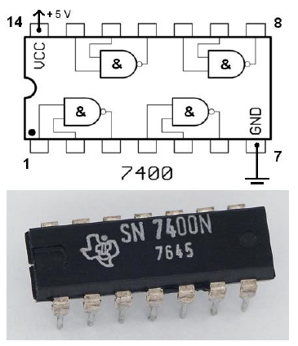
    - Breadboard
Figure 1. 7400 NAND DIP
    - Power Supply
    - Switches and LEDs
  - Circuit Components
    - 7404 inverter
    - 7408 AND
    - 7432 OR

Introduction:
Logic gates and Integrated Circuits: The 7400 family of Integrated Circuits (ICs) will be used throughout this course. The chips come in various packages, but the package used in these labs is a dual in-line package, otherwise known as a DIP as shown in Figure 1. In order to determine the polarity of the chip, a notch is put on one side of the chip. From a top view, pin one is on the left of the notch with other pins numbered sequentially in a counterclockwise manner.
The 7400 series is implemented using Transistor–transistor logic (TTL), which uses bipolar transistors (BJT) to form its integrated circuits. The 7400 family has many subfamilies made for special considerations, referred to by letters written after the family name; such as 74LS08, these subfamilies are summarized in Table 1.
Family | Meaning
74 – | Standard TTL
74L | Low-power
74H | High speed
74S | High-speed Schottky
74LS | Low-power Schottky
Table 1. 7400 Families
Figure 2 shows the internal logic of the 7404, 7408, 7432 chips.

Breadboard: In order to build the circuit, a digital design kit that contains a power supply, switches for input, light emitting diodes (LEDs), and a breadboard will be used. Figure 3.a shows a common breadboard, while Figure 3.b
shows how each set of pins are tied together electronically. Watch this video to understand how a breadboard works.
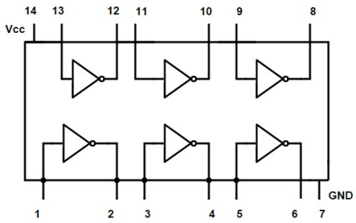 | 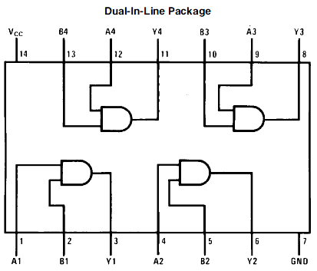 | 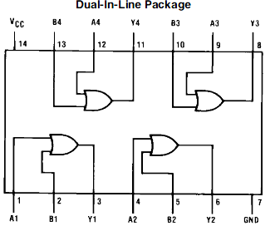
7404 hex inverters | 7408 Quad 2-input AND Gates | 7432 Quad 2-input OR Gates
Figure 2. Connection diagram of 7404, 7408m and 7432

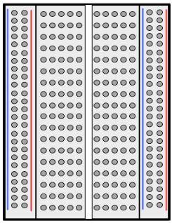 | 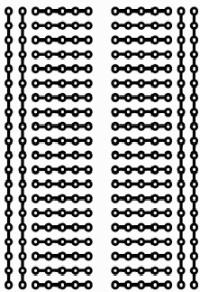
Figure 3.a: Breadboard | Figure 3.b Common connections

Steps your working environment

In Addition to the breadboard, you will need the following:
- Power supply to provide your components with 5Volts:
The power supply should be connected to your breadboard as following:

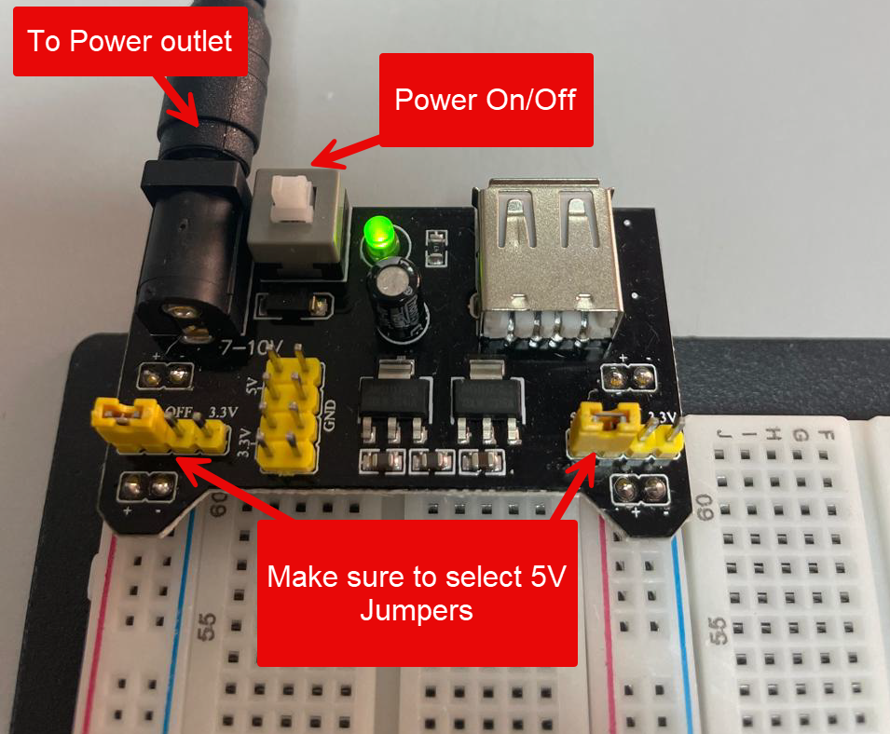

- Switches as inputs
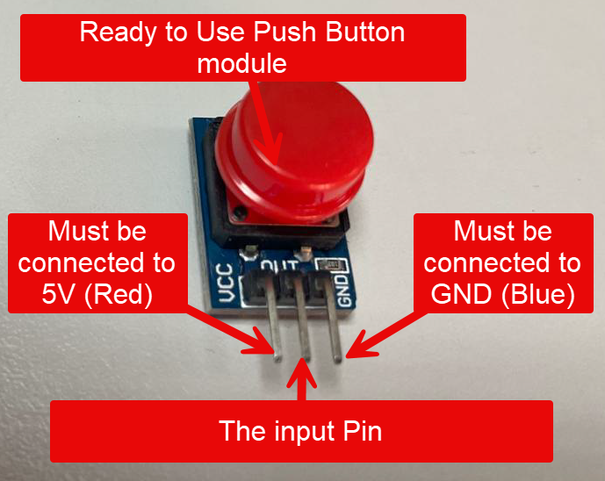
- LEDs as output.
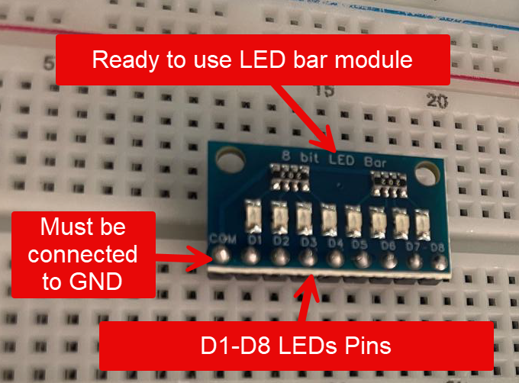

A sample circuit photo is given below:
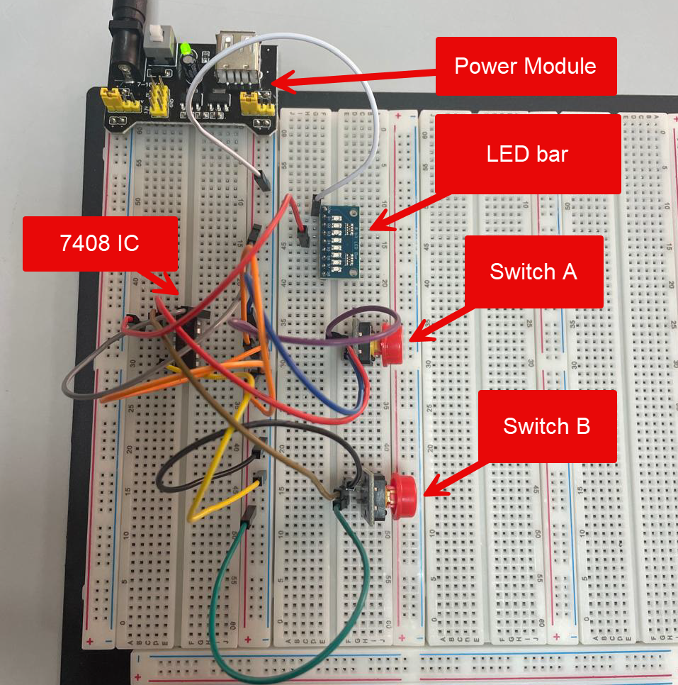

Lab Activities:

- Given the following digital circuit:
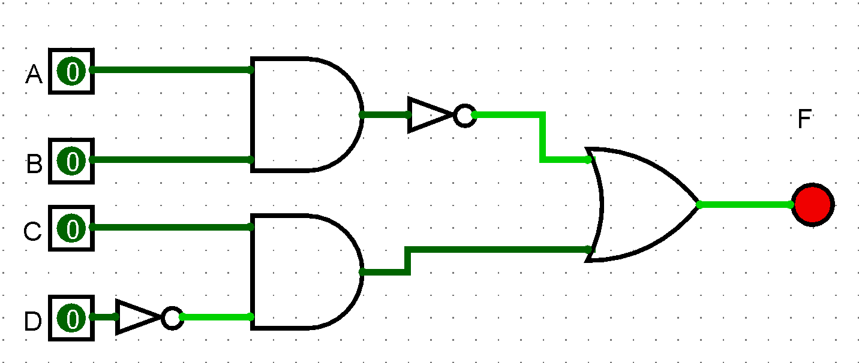

Implement the circuit on the Breadbaord and verify your answer.

- Given the following Boolean expression:

$$F\left(X,Y,Z\right)=\overline{X}.Y+X.Z+X.\overline{Y}.\overline{Z}$$
- Build the truth table for F.
- Draw the circuit
- Simulate the circuit in part b (using the simulation tool that was used in the previous lab) to verify your truth table obtained in part a.
- Implement the circuit in part b on the Breadboard.

